Name : Ganesh G

Subject: Java Internship (25 Sep 2023 – 25 Oct 2023)

Phone : +91 8095912681

Email : [ganeshg2k3@gmail.com](mailto:ganeshg2k3@gmail.com)

**Week - 4 Internship Task**

**Test-Based Adventure Game**

During my Fourth week of internship, I was given the task of creating a program for a Text-Based Adventure Game.

Introduction :

The Java-based text adventure game is an immersive experience set in a mysterious forest. Players navigate through a series of decisions that shape the storyline's outcome. The game's user-friendly interface ensures smooth interaction, while error handling maintains a seamless gaming experience. This project demonstrates fundamental Java programming concepts, offering a foundation for expanded gameplay and customization.

Program :

import java.util.Scanner;  
  
public class TextAdventureGame {  
  
 public static void main(String[] args) {  
 Scanner scanner = new Scanner(System.*in*);  
 *startGame*(scanner);  
 }  
  
 public static void startGame(Scanner scanner) {  
 System.*out*.println("Welcome to the Text Adventure Game!");  
 System.*out*.println("You find yourself in a dark forest. What do you do?");  
 System.*out*.println("1. Walk deeper into the forest.");  
 System.*out*.println("2. Stay where you are.");  
  
 int choice = *getUserChoice*(scanner, 2);  
  
 if (choice == 1) {  
 *choicePath1*(scanner);  
 } else if (choice == 2) {  
 *choicePath2*();  
 }  
 }  
  
 public static void choicePath1(Scanner scanner) {  
 System.*out*.println("You chose to walk deeper into the forest.");  
 System.*out*.println("You encounter a river. What do you do?");  
 System.*out*.println("1. Attempt to swim across.");  
 System.*out*.println("2. Look for a bridge.");  
  
 int choice = *getUserChoice*(scanner, 2);  
  
 if (choice == 1) {  
 System.*out*.println("You attempted to swim across the river. The strong current pulls you downstream.");  
 System.*out*.println("You manage to grab hold of a tree branch and pull yourself ashore.");  
 System.*out*.println("As you continue your journey, you stumble upon an old, abandoned cabin.");  
 System.*out*.println("What will you do?");  
 System.*out*.println("1. Enter the cabin.");  
 System.*out*.println("2. Keep walking.");  
  
 int cabinChoice = *getUserChoice*(scanner, 2);  
  
 if (cabinChoice == 1) {  
 System.*out*.println("You cautiously step inside the cabin. It is musty and dark, with remnants of a bygone era.");  
 System.*out*.println("You find a dusty journal that hints at hidden treasure buried deep in the forest.");  
 System.*out*.println("Excited, you decide to continue your adventure.");  
  
 // Implement the logic for the conclusion after finding the treasure  
 System.*out*.println("With the help of clues from the journal, you uncover the buried treasure and secure your fortune.");  
 System.*out*.println("Congratulations! You have successfully completed the game.");  
 } else if (cabinChoice == 2) {  
 // Implement the logic for continuing the journey without entering the cabin  
 System.*out*.println("You choose to ignore the cabin and keep walking through the forest.");  
 System.*out*.println("As you venture further, the trees thicken, and the path becomes increasingly obscure.");  
  
 // Implement the logic for the conclusion after journeying further  
 System.*out*.println("You eventually find your way out of the forest, having successfully navigated its challenges.");  
 System.*out*.println("Congratulations! You have successfully completed the game.");  
 }  
 } else if (choice == 2) {  
 System.*out*.println("You found a sturdy bridge and crossed the river.");  
 System.*out*.println("As you cross the river, you notice a faint light flickering in the distance.");  
 System.*out*.println("What will you do?");  
 System.*out*.println("1. Investigate the light.");  
 System.*out*.println("2. Ignore the light and continue your journey.");  
  
 int lightChoice = *getUserChoice*(scanner, 2);  
  
 if (lightChoice == 1) {  
 System.*out*.println("You follow the flickering light and stumble upon a hidden campsite.");  
 System.*out*.println("A group of friendly travelers offers you shelter for the night.");  
  
 // Implement the logic for the conclusion after staying with the travelers  
 System.*out*.println("After spending a night with the travelers, you bid them farewell and resume your journey.");  
 System.*out*.println("Congratulations! You have successfully completed the game.");  
 } else if (lightChoice == 2) {  
 // Implement the logic for continuing the journey without investigating the light  
 System.*out*.println("You decide to ignore the light and continue your journey through the forest.");  
 System.*out*.println("The path ahead seems to darken, and the sounds of wildlife grow more distant.");  
  
 // Implement the logic for the conclusion after journeying further  
 System.*out*.println("Despite the challenges, you successfully find your way out of the forest and emerge victorious.");  
 System.*out*.println("Congratulations! You have successfully completed the game.");  
 }  
 }  
 }  
  
 public static void choicePath2() {  
 System.*out*.println("You chose to stay where you are. The night falls and you decide to rest.");  
  
 // Implement the logic for the conclusion after choosing to stay  
 System.*out*.println("As the night passes, the morning sun illuminates a path leading out of the forest.");  
 System.*out*.println("You walk out of the forest, feeling refreshed and ready for new adventures.");  
 System.*out*.println("Congratulations! You have successfully completed the game.");  
 }  
  
 public static int getUserChoice(Scanner scanner, int maxChoice) {  
 int choice = 0;  
 while (choice < 1 || choice > maxChoice) {  
 try {  
 System.*out*.print("Enter your choice: ");  
 choice = Integer.*parseInt*(scanner.nextLine());  
 if (choice < 1 || choice > maxChoice) {  
 System.*out*.println("Invalid input. Please enter a number between 1 and " + maxChoice + ".");  
 }  
 } catch (NumberFormatException e) {  
 System.*out*.println("Invalid input. Please enter a valid number.");  
 }  
 }  
 return choice;  
 }  
}

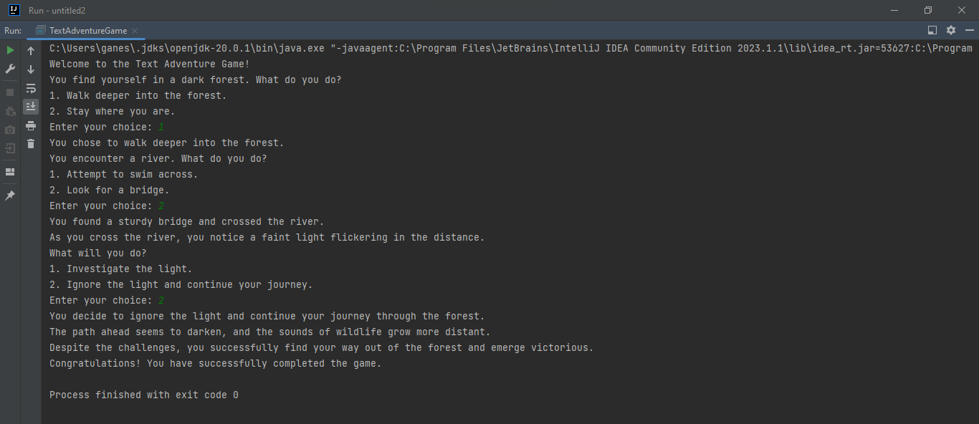Sample Input and Output :

Conclusion :

In summary, the Java-based text adventure game project successfully demonstrates effective implementation of core programming concepts. With its engaging storyline set in a mysterious forest, the game allows players to make crucial decisions that shape the outcome. The project's user-friendly interface, error handling, and multiple decision points showcase fundamental Java programming techniques. The integrated conclusion provides players with a satisfying end to their journey, highlighting the project's successful execution and adherence to best programming practices.